This term, children will be learning about "Significant Explorers", including:

Ibn Battuta, a Muslim traveler and scholar.
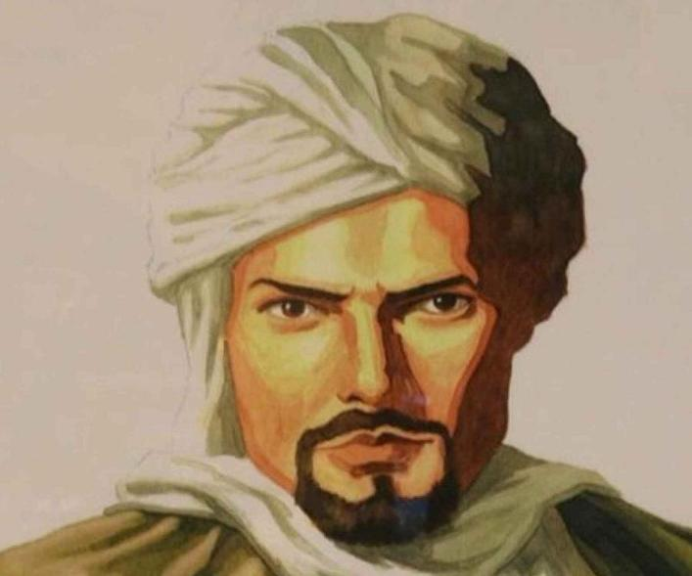

Neil Armstrong, the first human to set foot on the moon in 1969.
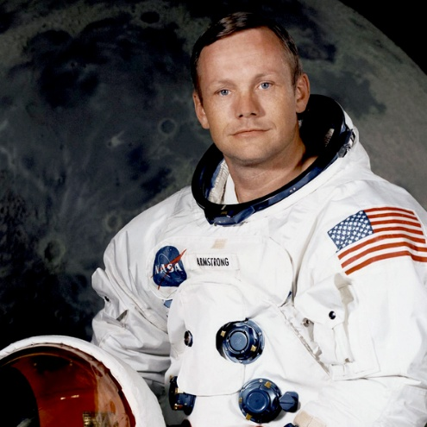

Tenzing Norgay, one of the first people to reach the summit of Mount Everest.
